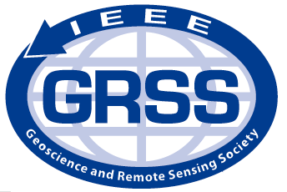
Sndlf
Geoscience and Remote Sensing Society

M2GARSS 2022 Voucher Request

IEEE Geoscience and Remote Sensing Society (GRSS) is devoted to supporting the education as well as the scientific development of young professionals and students (in all levels) in the fields of geoscience and remote sensing. With this purpose, the participation of Students, and young professionals (YPs), who have graduated from their last educational degree within the past 5 years, from the Middle-East and North Africa (MENA) region (Algeria, Bahrain, Egypt, Iran, Iraq, Israel, Jordan, Kuwait, Lebanon, Libya, Morocco, Oman, Qatar, Saudi Arabia, Syria, Tunisia, United Arab Emirates and Yemen) and Turkey, either for paper presentation or for simple attendance to M2GARSS 2022, is free of charge, thanks to the precious contribution of the IEEE GRSS. Attendance will include all the tutorials given in M2GARSS 2022.

In order to be eligible for free participation to M2GARSS 2022, students and YPs should have a certification which shows that they are a student or that they have graduated less than five years ago from an institution in the aforementioned countries. After a check by the Education and Student Affairs Chairs, eligible applicants will be provided with vouchers, which may be used to register free of charge afterwards. Please reserve your seat as space is limited!

In case you feel eligible, please fill in the following table and send back this form together with a certification to development@2022.m2garss.org

Application Date
First Name
Last Name
Birth Date
Email
Affiliation
Affiliation Country
Affiliation Address
Graduation Degree Achieved
Graduation Date
Graduation Country
IEEE GRSS Member? (Yes/No)
IEEE Number (if any)
M2GARSS Attendance (with paper/without paper)?

